Tryvium for Microsoft Azure
Built On Microsoft Teams

Hero Section
Orchestrate Enterprise AI on Microsoft Azure
Move beyond conversations and enable connected execution built on Microsoft Teams
Built on Microsoft Teams, Tryvium for Microsoft Azure orchestrates AI agents, human agents, workflows, and enterprise applications through one connected execution layer, enabling AI-led Employee Helpdesk and Customer Service Desk experiences alike.
CTA: Schedule a Demo

Why Enterprises Choose Tryvium for Microsoft Azure
Enterprise AI demands more than powerful models—it requires intelligent orchestration. Tryvium extends Microsoft Azure by seamlessly connecting AI agents, human expertise, enterprise applications, and workflows into a unified platform for autonomous, secure, and scalable experiences.
The result is faster time to value, enterprise-grade governance, and measurable business outcomes.
• AI-led Orchestration on Microsoft Teams
• Familiar user experience with enterprise-wide adoption
• Real-time coordination across your existing systems, workflows, and interactions
• Enterprise-grade governance and operational visibility
• AI-led execution with human oversight
• Faster adoption without changing employee behaviour
• Intelligent agent handover

Why Tryvium is the Right Choice for Modern Enterprises
As organizations transition to Autonomous AI Agents, Experience Orchestration becomes the foundation for intelligent service execution. It enables organizations to move beyond automation and escalation toward AI-led service execution powered by Experience Orchestration.

Traditional Automation Escalation Model vs. Tryvium for Microsoft Azure

Traditional Automation Escalation Model | Tryvium for Microsoft Azure
Automation → Escalation | AI Agent Orchestration
Bot → Queue → Agent | AI Agent → Orchestrate → Resolve
Reactive service delivery | Intelligent service execution
Multiple disconnected tools | Unified orchestration layer
Manual workflow coordination | Automated workflow execution
Limited visibility | End-to-end operational insights
Human agents as bottlenecks | Human governance engaged when needed
Ticket-focused operations | Outcome-driven experiences

AI- Agent Orchestrated Solution on Microsoft Azure
Empowering enterprises modernize employee helpdesk and customer service desk through AI-led orchestration, intelligent automation, and scalable service execution powered by Microsoft Azure.

AI-led Employee Helpdesk
AI-Led Employee Helpdesk Built on Microsoft Teams
Enable employees to access support, information, and services through a familiar interface while reducing manual effort for support teams.
• Automate HR, IT, and internal support operations
Streamline routine employee requests and service workflows through AI-led automation.
• Coordinate AI agents and human support teams
Intelligently route requests between AI agents and support teams for efficient resolution.
• Maintain persistent interaction context
Preserve conversation history and employee information across every interaction.
• Reduce routing complexity and escalations
Automatically direct requests to the right resource without manual intervention.
• Deliver faster internal support experiences
Improve response times and resolution speed across employee support functions.

AI-led Customer Service Desk
AI-Led Customer Service Desk Built on Microsoft Teams
Coordinate customer interactions, workflows, support teams, and AI agents through one connected platform designed for modern service operations.
• Omnichannel customer engagement
Deliver consistent customer experiences across voice, chat, email, and digital channels.
• AI-led interactions with human governance
Enable AI agents to handle routine inquiries while maintaining human oversight when needed.
• Continuous customer context across channels
Maintain a unified view of customer interactions across every touchpoint.
• Workflow-driven resolution acceleration
Automate processes and approvals to reduce resolution times and improve service efficiency.
• End-to-end customer journeys
Connect interactions, workflows, and systems to deliver seamless customer experiences from start to resolution.

Enterprise Challenges, Orchestrated
How Tryvium for Microsoft Azure Orchestrates AI-led Operations
Empowers organizations to simplify service operations, connect workflows, and orchestrate AI-led employee and customer experiences through a unified execution layer.
Unified Experience Orchestration
Coordinate AI agents, human agents, workflows, and enterprise applications through a single orchestration layer that eliminates operational silos.
Connected Workflows & Systems
Unify fragmented processes by connecting interactions, workflows, automation, approvals, and enterprise applications in real time.
AI-Led Service Execution
Enable AI agents to automate routine tasks, accelerate resolution, and seamlessly engage human experts when required.
Persistent Context Across Every Interaction
Maintain conversation, workflow, and operational context across every employee and customer interaction.
Scalable Operations with Governance
Scale AI-led service operations with enterprise-grade governance, visibility, compliance, and human oversight.

Enterprise Integrations, Simplified
Built on Microsoft Teams and designed to integrate with your ecosystem, Tryvium for Microsoft Azure connects employee support, customer service, workflows, and business applications through a flexible integration ecosystem.
Seamless Integration with: Microsoft Teams, Dynamics 365, ServiceNow, Salesforce, Zendesk, BMC Remedy, Ivanti, Cherwell, CRM platforms, ITSM platforms, and more.
Enterprise Readiness & Ecosystem
Building Security, Governance & Compliance Built into Every Interaction
Tryvium for Microsoft Azure enables organizations to deploy AI-led employee and customer experiences with enterprise-grade security, governance, and operational controls.
Data Privacy
Data protection principles are embedded across interactions, workflows, integrations, and AI operations to help organizations maintain compliance and safeguard sensitive information.
Human-Governed AI
AI-led execution remains transparent, explainable, and governed through configurable controls, ensuring human oversight when needed.
Enterprise-Grade Security Controls
Role-based access, encryption, monitoring, auditability, and governance frameworks help organizations maintain secure and compliant service delivery at scale.

Microsoft Validated & Recognized
• Unify Certified (1 of 7 globally)
• Solution Certified for Microsoft Teams
• Microsoft Modern Work Certified Software for Teams AI Contact Center
• Marketplace availability and ecosystem alignment

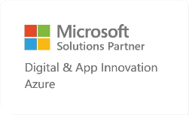

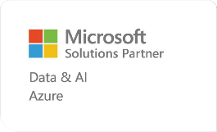
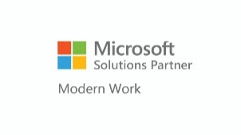

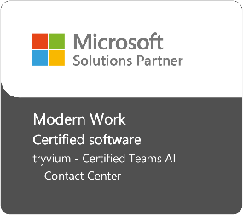
https://microsoftpartners.microsoft.com/abs/contact-center-solutions/
Teams Contact Center - Microsoft Teams | Microsoft Learn
Final CTA
AI-Led Experience Orchestration
Experience Orchestration Built on Microsoft Teams
Delivering AI-led employee and customer experiences with Tryvium for Microsoft Azure.
CTA: Schedule a demo

